 | Chapter 2 KFS Overview
The KFS is a community source project charged with development of an integrated set of financial services for higher education. The KFS offers a comprehensive suite of modules including Flexible Chart of Accounts, General Ledger, Decision Support, Accounts Receivable, Capital Asset Management, Labor Distribution, Purchasing, Accounts Payable, Endowment, and Pre- and Post-Award Contract Administration.
A key component in the KFS is an “electronic documents” environment called e-doc in which electronic documents are initiated on a personal computer, electronically routed through an approval process, and eventually passed to the General Ledger. KFS is important to those who use and process financial information for a variety of reasons. The KFS reduces paper processes; enables faster turnaround and allows for decisions to be made based on up-to-date information; provides built-in checks and balances reducing mistakes and the need to correct errors; gives more control and management flexibility to documents; and creates audit trails.
Topics | KFS Modules 2-2  KFS Architecture 2-4  E-Doc Fundamentals 2-13  Basic E-Doc Operations 2-27

How to Use This Chapter
This chapter is intended to be a guide for common operations of e-doc as a foundation for subsequent chapters.

KFS Modules
“Kuali” is an umbrella of applications development, under which smaller applications known as modules are developed to support coarse-grained end-user tasks. Modules are portions of larger programs that carry out specific functions. They can be implemented alone or can be combined with other modules.
The KFS’s modular architecture allows institutions to implement only the functional elements they need. In this way, the KFS can be scaled to meet the needs of institutions of any size.

Core Modules
Currently falling under the Kuali umbrella are the Kuali Nervous System (KNS), which encompasses infrastructure components, and the Kuali Enterprise Workflow (KEW), which automates routing of e-docs (electronic documents) for approval according to specified business rules. These two modules are considered "core" modules, since they are necessary for other functional modules to operate. The specifications are available for institutions to develop their own interfaces to the core system modules.

KNS
The KNS is the underlying infrastructure code that any KFS module may employ to perform its functions. The KNS is functionality common to many modules. Examples include creating custom attributes, attaching electronic images, uploading data from desktop applications, lookup/search routines, and database interaction. The KNS is a core technical module composed of reusable code components that provide common pieces of functionality. The KNS is a technical framework that enforces consistency in the applications that use it. It promotes adherence to the architectural principles and development standards defined by the Kuali architects. The KNS also provides a stable core of development tools providing a more efficient development paradigm.

KEW
The KEW is the Kuali infrastructure service that electronically routes an e-doc to its approvers in a prescribed sequence, according to established business rules based on the e-doc content. It is considered a general-purpose electronic routing infrastructure or “workflow engine.” Client applications use the KEW to automate and regulate the routing and approval processes for the transactions/documents they create. It starts with an e-doc that users compose in a client application such as the KFS or some other Web application which requires routing and approval of documents.
The KEW routes the e-doc electronically to the attention of designated individuals, based on University or departmental business rules and policies. Via this centralized routing system, users can access and search for many types of e-docs from various client applications, such as HR, Purchasing, Travel, Research Administration, Timekeeping, etc.; this is accomplished from a single location, the Action List and Doc Search. The Route Log for a given document allows users to follow its progress. The KEW streamlines mediated business processes across the enterprise.

KFS Modules
The KFS is a functional module (application) that interfaces with the core modules of KNS and KEW. It is also an application that itself is comprised of many modules (sometimes referred to as sub modules). KFS includes a base system of Chart of Accounts, Financial Transactions, and General Ledger. Additional modules that can be implemented when institutions identify a need, include: Accounts Receivable, Budgeting, Capital Assets Management, Endowment, Enhanced Decision Support/Reporting, Labor Distribution, Purchasing/Accounts Payable, Pre- and Post-Award Research Administration.
- Chart of Accounts: controlling tables that define financial information.
- General Ledger: repository of all financial and budget information.
- Financial Transactions Processing: allows account managers and organizations to transact financial business through their computers, rather than by using paper forms.
- Reporting/Decision Support: allows account managers and others to access financial information and provide tools to assist in the analysis of the financial information.

KFS Architecture
The three main parts to the KFS are e-doc, where users initiate and update financial data; the General Ledger where financial data is stored; and Decision Support, from where users can retrieve data from the General Ledger.
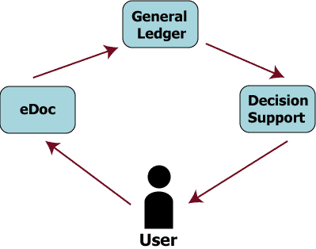
Figure 2-1 Three main parts of the KFS

E-Doc
In the KFS, department personnel initiate a transaction from their desktop Web browser. This transaction is called a document or an e-doc. The initiator receives immediate feedback on the validity of the document both in light of the appropriateness of data and the compliance with business rules. A valid document is then routed to one or more designated approvers based on the type and content of the transaction. Fully approved transactions are sent to the General Ledger at a later time. The engine that enables routing is called Kuali Enterprise Workflow (KEW).
Anyone who initiates, reviews or approves financial transaction may be a user of an e-doc, including:
- Departmental support staff, professional staff, and faculty
- Fiscal Officers and Delegates
- Contracts and Grants Principal Investigators
- Deans, Directors, and Department Chairs
- Administrators

General Ledger
General Ledger is the official repository of all the University’s financial and budget information. It stores account balance and budget information for multiple fiscal years as well as detailed records of all financial transactions. Whenever a financial transaction in an e-doc is fully approved, it is recorded in the General Ledger and affects the balances.

Decision Support
Decision Support is a collection of online services that provide access to the data within the KFS. Decision Support includes inquiries and reports available in the KFS. You can use Decision Support to:
- View account budgets, balances, and individual transactions.
- Retrieve standard reports such as the Account Status or Account Transaction Listing.
- Generate pre-defined or custom reports from financial and system data.

Chart of Accounts
Chart of Accounts (COA) is the set of tables that define the codes and coding structures within KFS Attributes, such as Accounts, Organizations, and Object Codes that are all part of the COA. The COA exists primarily to support and validate entries into the General Ledger (G/L). For example, transactions cannot be applied to an account in the G/L unless that account first exists in the COA. These COA attributes are associated with additional attributes, such as the Fund Group or Organization associated with an account, or the Object Level that is associated with an object code. Defining these attributes and their various relationships is how the financial structure of an institution is defined. By leveraging the COA, an institution can organize its information to support activities such as e-doc routing, management of internal controls, and internal and external reporting. The KFS features a very flexible, multiple chart of accounts capability that can accommodate the needs of Carnegie Class institutions, from small community colleges to large multi-campus research institutions.

Kuali Enterprise Workflow (KEW)
Workflow is used to route a document by matching attributes of a transaction with existing rules that indicate where a transaction with those particular attributes should go. Most commonly, Workflow is used to collect approvals. The path of approval can be influenced by the type of transaction and the content of the transaction itself. Commonly, financial documents pass through the Account Level routing (Fiscal Officer) and organization review routing.
For more information about KEW, see Chapter 7 "Error: Reference source not found” in Chapter 7, page Error: Reference source not found.

Access
KFS access is determined by workgroups and document types. Depending on institutional requirements and implementation, different access rules can be constructed and associated with specific document types or groups of documents and with specific users or groups of users.

Workgroup
A Workgroup is a collection of users who share a similar responsibility and business function. When a document routes to a Workgroup all members of the Workgroup can see that document in their action lists. Once any member of the Workgroup takes an action on that document it is removed from the action list of all other Workgroup members. Access to particular Document Types can also be controlled by Workgroups.

Document Type
Document Type is used to distinguish between the different types of transactions possible in the KFS (e.g., Cash Receipts, Disbursement Vouchers, and Transfers of Funds). A Document Type generally allows users to perform a set of functions (transferring an expense, or requesting a disbursement) and contains business rules particular to that function.
While most document types in the KFS are available for anyone to initiate, there are some that are restricted to users who are members of particular workgroups. Individual document types and their restrictions are available in Chapter 3.

Roles
Roles determine what options are available to a KFS user. Some roles are determined by the user’s relationship to a particular document. The role of Initiator is automatically assigned by the system to the user who creates a new e-doc. Other roles give additional permissions or options in addition to what normal KFS users might possess. For example, a user could be an Approver for a specific e-doc or have the additional role of Administrator, which gives the user options that a normal Approver would not have. It is possible, and sometimes common, for a user to have multiple roles. The roles are Initiator, Approver, Delegate, Reviewer, Administrator, and Superuser:

Initiator
As an Initiator you can create documents. Any Kuali user may initiate most of the document types, however, an initiator may be required to belong to a Workgroup for certain restricted document types (for example, Journal Voucher).

Approver
As an Approver you can approve the documents, at any route level (including Ad Hoc routing). As a document moves through Workflow, it moves one route level at a time. An Approver operates at a particular route level of the document. The first route level for most Financial Documents is the Fiscal Officer route level (also called the Account Level). The screen view and available action options of a document may vary, depending on whether the document is at that Approver’s route level, or at some other route level.

Delegate
As a Delegate you can approve documents at the Account Level of routing, as if you were the Fiscal Officer. Fiscal Officers can delegate the approval authority to other users based on attributes of a specific transaction, such as document type and dollar amount. There are two kinds of delegates: Primary Delegates and Secondary Delegates. While documents route directly to Primary Delegates instead of routing to Fiscal Officers, they route to Secondary Delegates in addition to Fiscal Officers. The Secondary Delegates have a special filter option in their action list, which allows them to retrieve documents for which they have been given approval authority.

Reviewer
As a Reviewer, a document is ad-hoc routed to you for Acknowledgement or FYI.

Administrator
As an Administrator you can give blanket approval on most transactions you initiate or for which you are an Approver. Blanket approval is a special workflow option that allows the user to force a document into approved status without waiting for the normal routing process to be completed.

Superuser
As a Superuser you can fully approve any enroute document, can approve or disapprove any document at its current route level, and can cancel any document that has not been fully approved.

Navigating through KFS

Menu Tabs
The KFS is accessed by simply typing the URL address into your browser’s address bar. The KFS menus are organized by tabs. The Main Menu screen displays the list of transactions and functions that the user is permitted to initiate. The Administration screen lists various maintenance transactions that are available, which update the reference tables used by the KFS.
Access to initiate documents on the Administration Menu is restricted to members of the KUALI_ROLE MAINTENANCE workgroup.
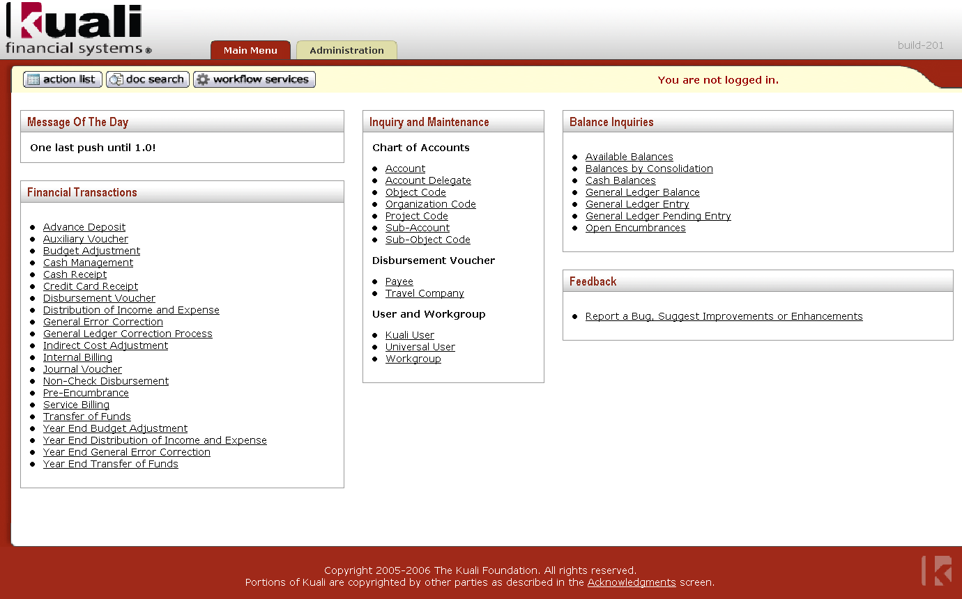
Figure 2-2 The KFS Main Menu contains menus for user functions.

Message of the Day
The Main Menu tab includes the Message of the Day in the upper left corner where an authorized user can update the message.
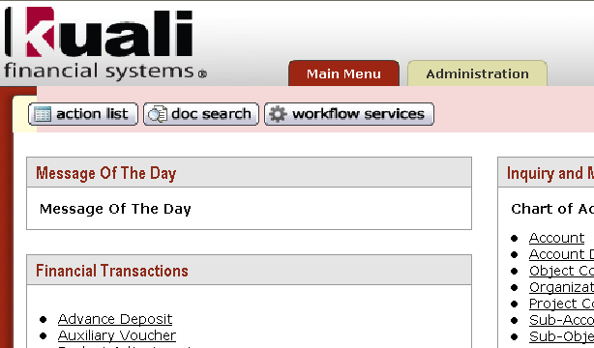
Figure 2-3 Message of the Day
For information about how to change the Message of the Day, see "Message of the Day” in this chapter, page 8.
When the message of the day is blank, the Message of the Day section in the Main Menu tab does not show.
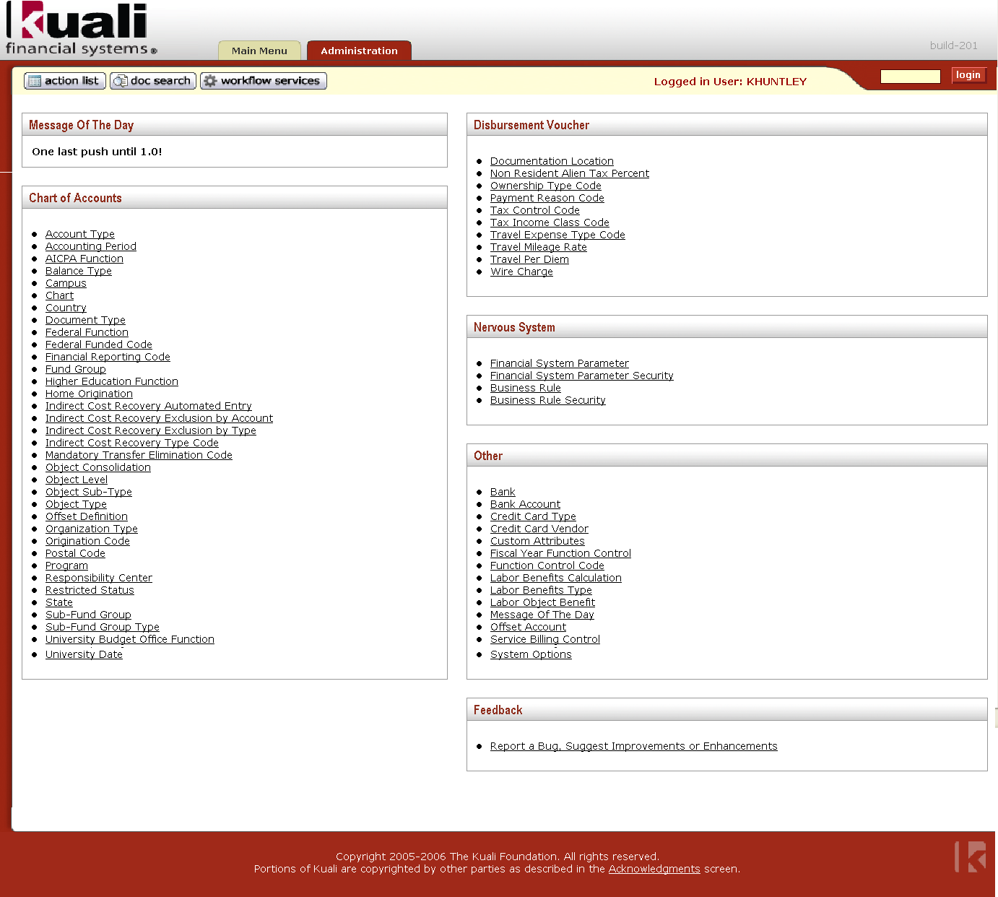
Figure 2-4 The KFS Administration Menu contains menus for maintaining reference tables.

Logging on to the KFS
When selecting an item in the Main Menu or the Administration tab for the first time in a session, the KFS asks for a user ID and password. The KFS performs user authentication and authorization to restrict access to business transactions, according to the prevailing institutional practices.
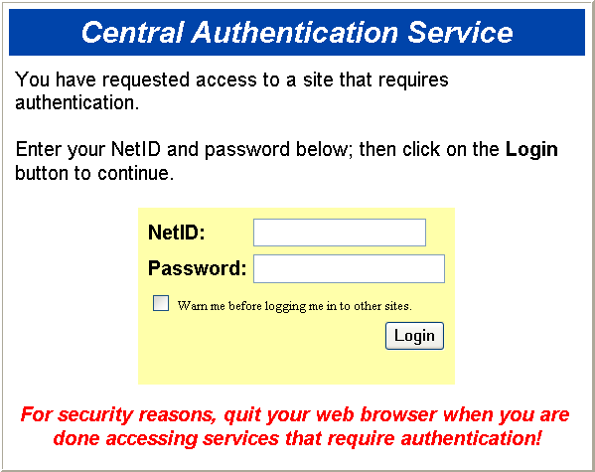
Figure 2-5 The KFS authenticates user based on the prevailing institutional practice.
Once you have logged on, you are not asked to logon again until you logoff from the system by closing the browser.

Logging Off
To logoff from the KFS, simply close the Web browser by clicking the standard browser’s Close button located in the upper-right corner.

E-Doc Fundamentals
The following section describes the page layout, common attributes of an e-doc, and basic functions.

E-Doc Screen Layout
An e-doc document consists of a Document Header and a Document Body. The Document Header at the upper right corner contains the system information about the document. The document body is organized in a stack of labeled tabs that is similar to file folders. Based on the type of document, a different set of tabs is displayed. To facilitate the document input process, an initiated document opens with required tabs expanded and the optional tabs collapsed.
Show/Hide Buttons
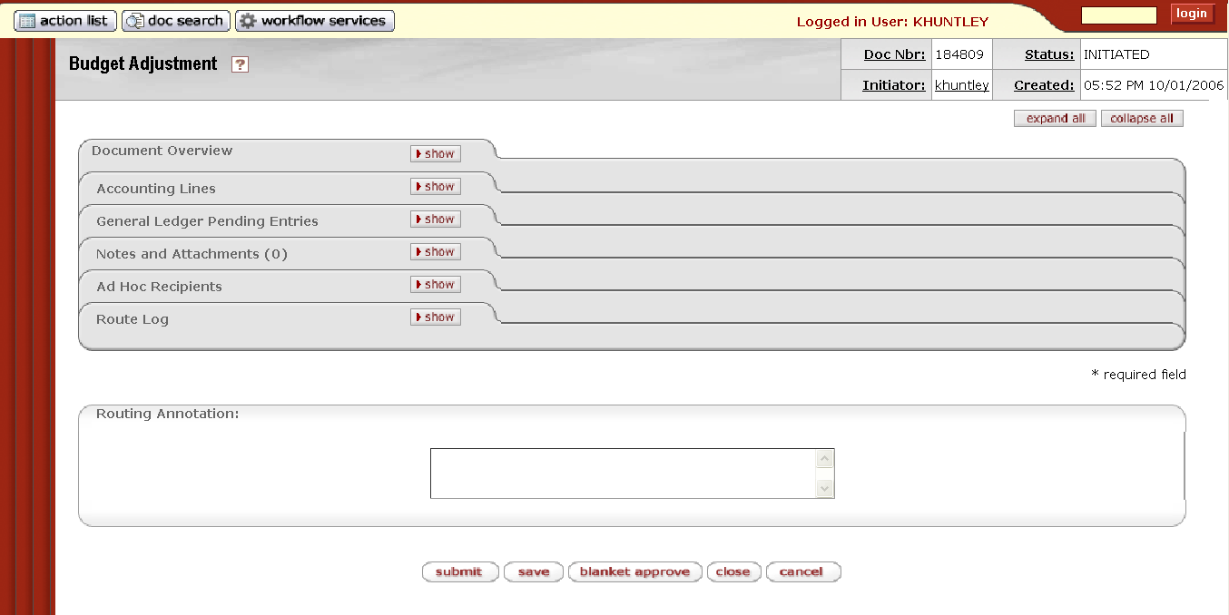
Document Header
Expand All/Collapse All Buttons
Figure 2-6 There are various components in an e-doc page layout.

Document Header
Table 2-1 Basic Information in the Document Header
Title | Description
Document Number (Document Nbr) | The unique number used to identify each document. The KFS assigns a sequential number to each document when it is created, regardless of the type of document.
Status | Identifies the status of a document within the Workflow process
Initiator | Identifies the user ID of the document initiator
Created | Identifies the time and date the document was created

For status definitions see “Error: Reference source not found” in Chapter 7, page Error: Reference source not found.
Table 2-2 Optional Information in the Document Header
Title | Description
Copied from Document ID | The KFS allows users to create new financial documents based on previous transactions by use of a copy function. When one document is copied from another, the document number of the copied document appears here.
Correct Document ID | The KFS gives you the option of reversing a fully approved financial transaction through the use of the Error Correction function. When one document is a correction of another, the document number of the document being corrected appears here. This information is displayed only when the document was created using the Error Correction feature from within an existing document.

Expand All /Collapse All Buttons
You may expand or collapse all tabs by clicking expand all or collapse all.

Expanded Tabs
Click expand all to expand all of the e-doc tabs.
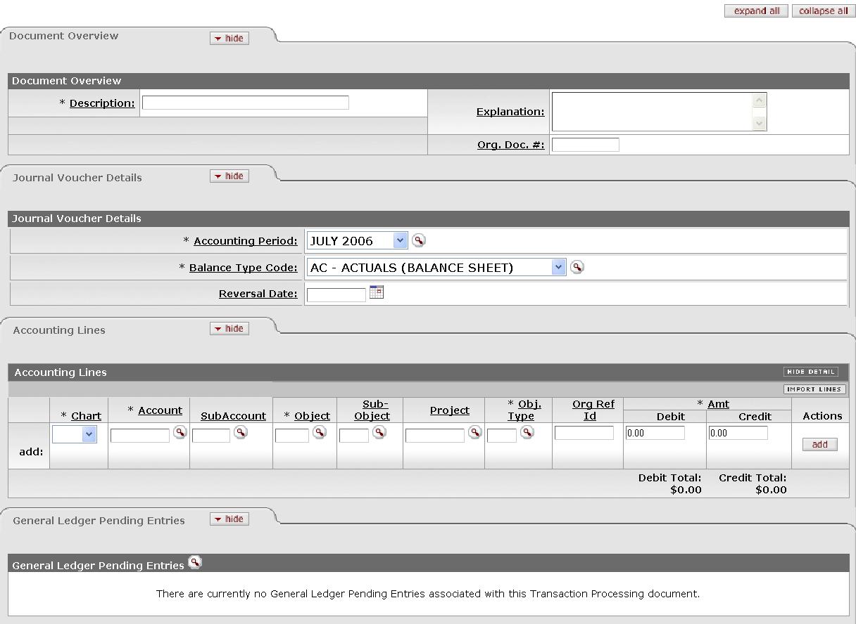
Figure 2-7 Click expand all to expand the e-doc tabs.

Collapsed Tabs
Click collapse all to collapse all of the e-doc tabs.
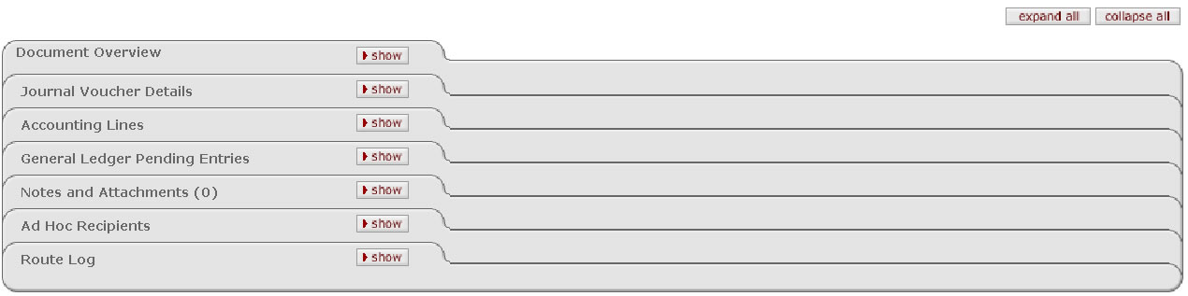
Figure 2-8 Click collapse all to collapse the e-doc tabs.

Show/Hide Buttons
Use show or hide on the tabs to expand or collapse an individual tab.
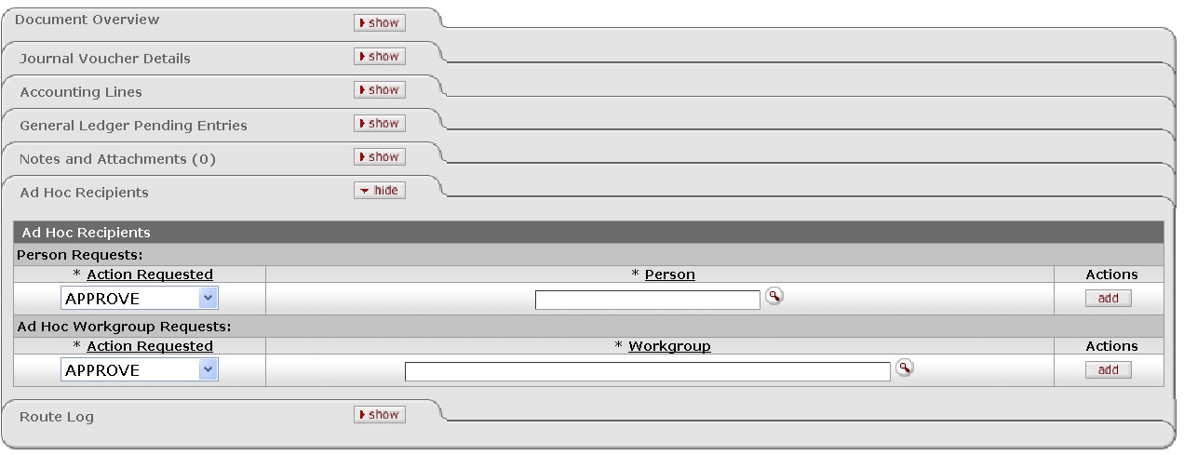
Figure 2-9 The show and hide buttons on the e-doc tab allows you to expand or collapse an individual tab.

Required Fields
All of the required fields are denoted with an asterisk. You cannot submit the document until all required fields are entered.
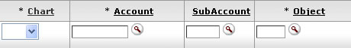
Figure 2-10 Required fields are denoted with an asterisk.

Standard Links and Icons
Since the KFS is a web-based application, hyperlinks and icons are used for navigation. Clicking the hyperlinks and icons allows you to drill down into the document detail or to obtain additional information.

Help
There are two types of help navigation available in the KFS: one is a Help icon and the other is a hyperlink.
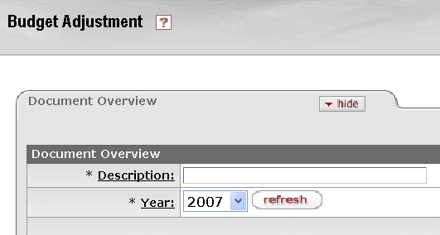
Figure 2-11 There are two ways to get help in the KFS.

Help Icon
When you click the Help icon by the document title, the help screen displays the description of the screen that you are in. When you click the field hyperlink to the right of the input area, the help screen displays the definition of the field and its type.
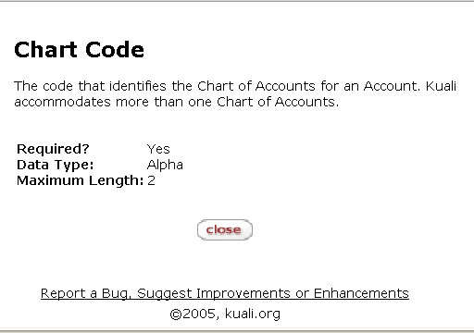
Figure 2-12 The help screen displays the field description, data type and length in a pop-up window.

Field Lookup
The round magnifying glass icon allows you to look up the reference table information and displays a list of valid values for you to select from in order to avoid data entry errors.
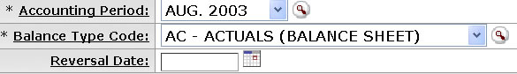
Figure 2-13 The field lookup is accessible by clicking the round magnifying glass icon.

To look up valid values, follow these steps:
  - Fill in one or more search criteria or leave all the search criteria blank to retrieve all.
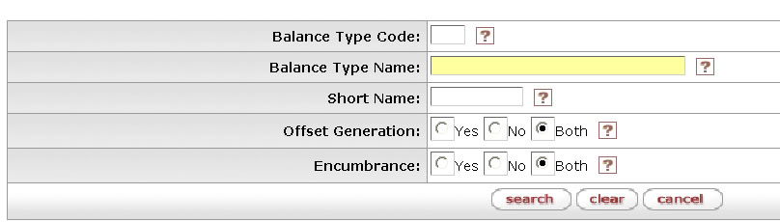
Figure 2-14 To get a list of valid values in the field lookup, fill in one or more search criteria.
Search criteria may be specified by:
Typing data into any combination, all or none of the listed search fields.(Most search fields change the typed data to uppercase for the search.)
Using wildcards at the end of or within a string of characters to represent any character or characters. The symbols * and % can be used as wildcards.
Using range operators on numbers and dates are >, <, >=, <=, or
All operators except '..' should be before a date value.
The operator '..' should separate date values.(Dates should be specified as mm/dd/yyyy.)
Using logical operators & (AND) and | (OR) with multiple search parameters.
  - Click search.
The KFS displays the list of applicable values that you have requested. Once the value list is displayed, you may take one of the following actions by clicking the hyperlinks labeled a through e in the following picture.
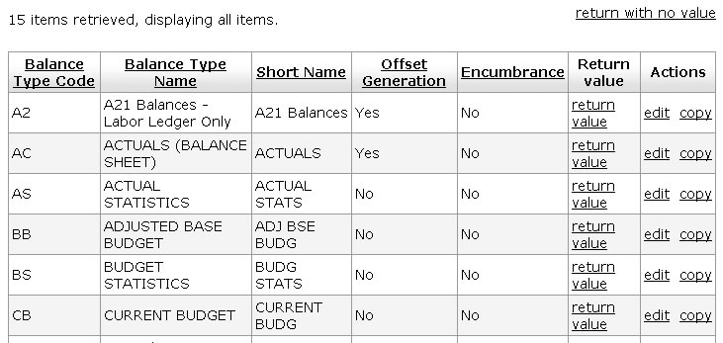
a
b
cx
Figure 2-15 The KFS retrieves valid values in the field lookup.
d
e

a Click return value to select the code.
b Click return with no value to cancel the search (or click cancel).
c Click the name of the column to sort the retrieved values by that column.
d Click edit to edit the table entry using a maintenance e-doc screen.
e Click copy to create a new entry in the table based on the selected value.

Exporting the data in the CSV, Excel, or XML format
If you wish to export the result of the table lookup to your local computer, either in the CSV, Excel, or XML format, simply click the export option link.
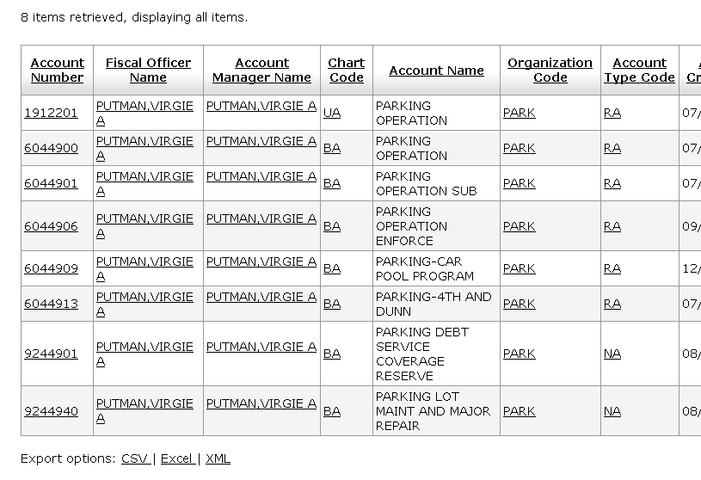
Click the export options link to export the table values
Figure 2-16 You may export the result of the lookup.

When you click the link, you are prompted to click either Open, Save, or Cancel. Click one of the buttons and follow the standard Window's prompts.
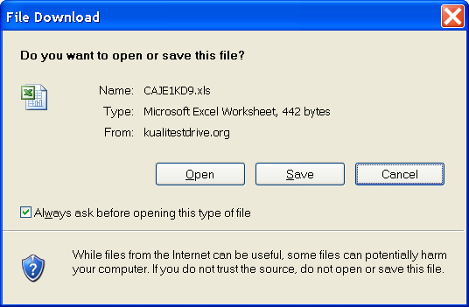
Figure 2-17 File Download Dialogue

Drilldown
When you see the link or icon associated with the retrieved data, you can drill down into details. There are some standard drilldown features within the KFS.
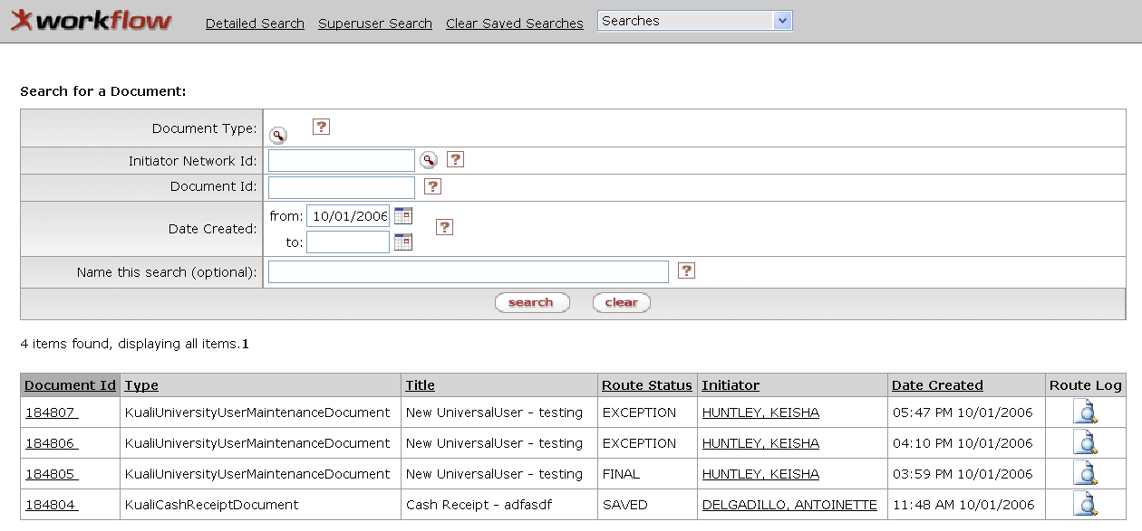
c Route Log Lookup
a Document ID Drilldown
b User Drilldown
Figure 2-18 The KFS has standard drilldown features.
a Document ID Drilldown
The Document ID link retrieves the e-doc document for you to view or edit the document.
b User Drilldown
The user hyperlink takes you to a workflow user report.
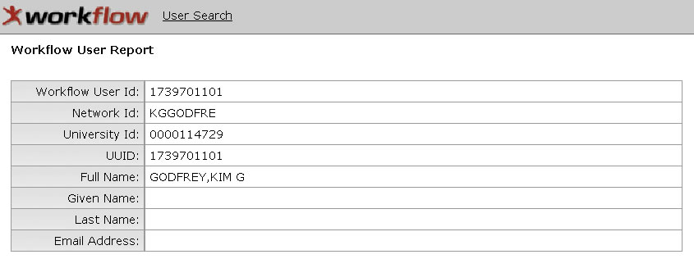
Figure 2-19 The Workflow User Report shows details about the user.
 | c Route Log Lookup  Clicking the Route Log icon takes you to the Route Log that contains two tabs summarizing the routing activities: the Action Taken tab logs prior events and the Pending Action Requests tab logs known future events, from which you can see the current Workflow action requests.  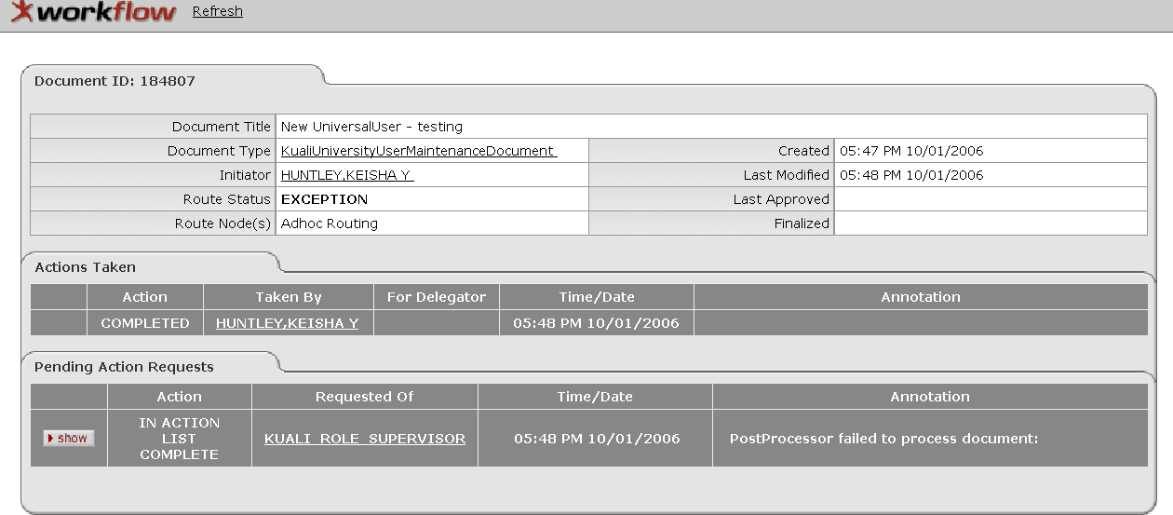  Figure 2-20 Clicking the Route Log icon displays the workflow information.
 | For more information about the Route Log, see “Error: Reference source not found" in Chapter 7, page Error: Reference source not found.

Standard Tabs
 | While the tabs contained in various e-docs vary from one document type to the other, there is a set of standard tabs that is part of every e-doc. They are Document Overview, Notes and Attachments, Ad Hoc Recipients, and Route Log tabs. The basic functionality of these tabs is explained below:

Document Overview Tab
The Document Overview tab identifies the document. The Description field is a required field on every e-doc. The tab also includes another field called Explanation or Justification depending on the document type. The field may or may not be required according to the business rule of the document type.
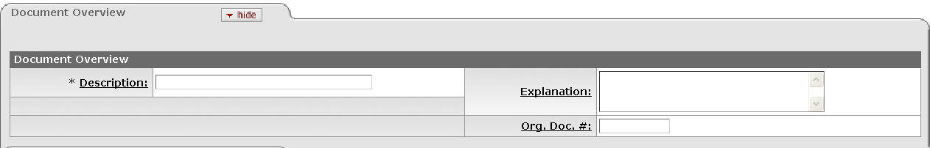
Figure 2-21 The Document Overview tab with Explanation Field
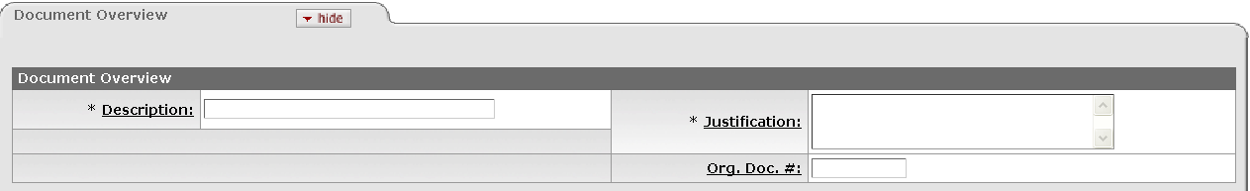
Figure 2-22 The Document Overview tab with the Justification Field
Table 2-3 Document Overview Tab Definition
Title | Description
Description | Required. Enter the description for the document.
Explanation or Justification | Optional. Enter comments.
Org Doc # | Optional. Enter the numeric document identification that may include departmental or organizational information.

Notes and Attachments Tab
The Notes and Attachments tab displays user notes, attachments, or system-generated remarks about the document. The number of notes and/or attachment is indicated on the tab.
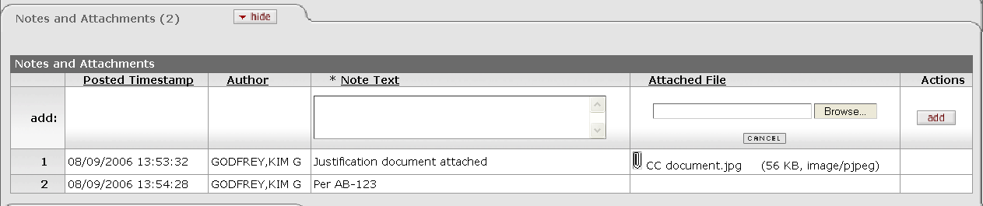
Figure 2-23 The number of notes and/or attachment is shown in parenthesis in the Notes and Attachments tab.

Table 2-4 Notes and Attachments Tab Definition
Title | Description
Posted Timestamp | Display only. The time and date when the attachment or note was posted
Author | Display only. The full name of the user who has added the notes or attachments
Note Text | Required. Enter comments.
Attached File | Optional. Select the file to attach by clicking Browse and following Window's standard Choose File dialog box. Click CANCEL to clear the file name that you have selected.  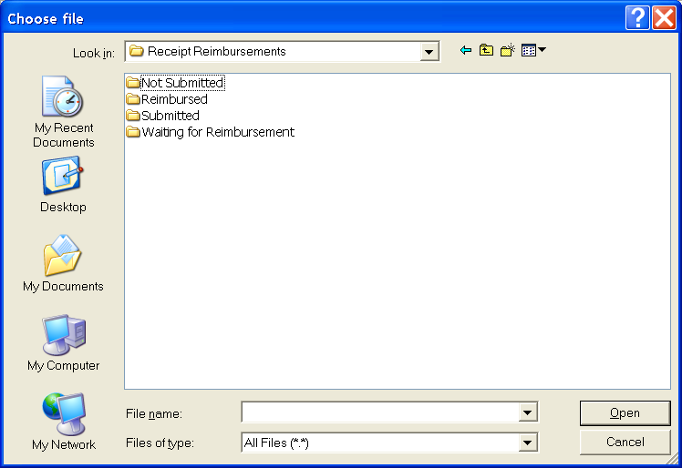  Figure 2-24 Choose File Dialog Box
Actions | Click add to add the current line in the Accounting Lines tab. Delete functionality does not exist -- See KULFDBCK-522 in JIRA.

Ad Hoc Recipients Tab
The Ad Hoc Recipients tab allows you to interrupt the normal workflow routing of the document and include individuals or workgroups in the routing path. The Ad Hoc Recipients tab has two sections: Person Requests and Ad Hoc Workgroup Requests. Use one or both of the sections to route the document to a person, workgroup, or both.
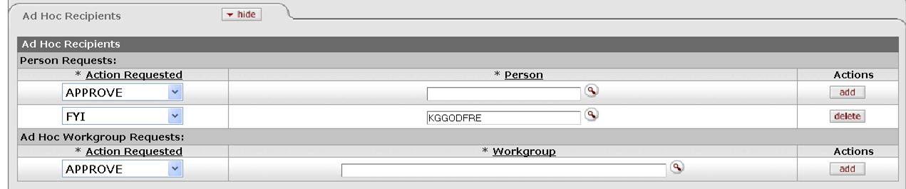
Figure 2-25 Ad Hoc Recipients Tab
Table 2-5 Ad Hoc Recipients Tab
Field Name | Description
Action Requested | Required. Select the desired action from the Action Requested list. The choices are APPROVE, ACKNOWLEDGE, and FYI.  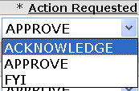  Figure 2-26 Action Requested List in Ad Hoc Routing
Person | Required when you wish to route the document to an individual. Enter a user ID or select it from the UserID lookup .
Workgroup | Required to route the document to a workgroup. Enter a workgroup name or select it from the Workgroup lookup .

Click add in the Actions column to add the current line.
Click delete in the Actions column to delete the current line.
For more information about the Ad Hoc routing see “Error: Reference source not found” in Chapter 7, page Error: Reference source not found.

Route Log Tab
The Route Log tab displays the workflow status details.
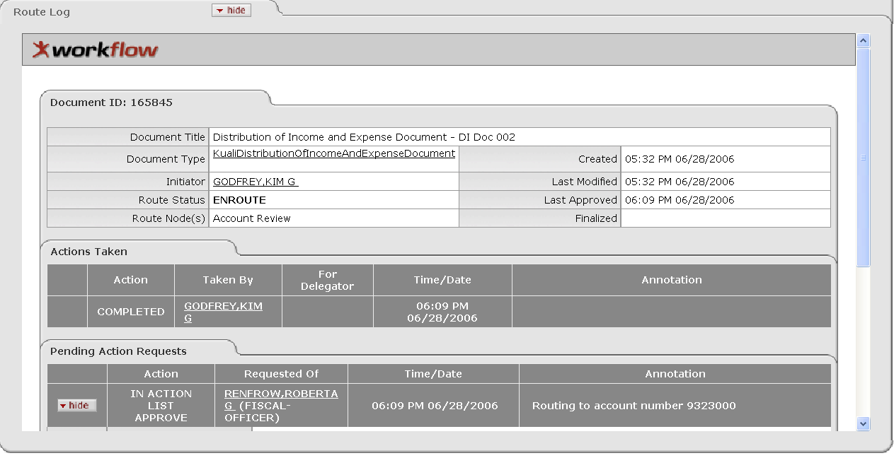
Figure 2-27 The Route Log tab displays the workflow status and actions taken.
For more information about the Route Log, see "Error: Reference source not found” in Chapter 7, page Error: Reference source not found.

Basic E-Doc Operations
This section describes the basic e-doc operations with which a KFS user should be familiar.

Initiating a Document
  - Select the document link from the main menu (Figure 2-2).
  - If you have not logged into the system, you are asked to enter user ID and password (Figure 2-5).
  - Complete required tabs for the document.
  - Click submit to route the document for approval.
The requirements to complete an e-doc are explained later in the respective chapter for each document type. For the steps for routing the document, see “Routing a Document” later in this chapter, page 29.

Copy a Document (Initiating a Document Based on another Document)
You may initiate a new document based on an existing document.
  - Retrieve the document from which you wish to copy.
For the steps to retrieve an e-doc, see “Searching for a Document” later in this chapter, page 31.
  - Click copy from the list of workflow action buttons (Figure 2-6).
  - A new document is created with a new document ID.
Copied from Document ID information is displayed in the Document Header and also in the Notes and Attachments tab of the document.

Figure 2-28 Copied from Document Id displays when you copy a document

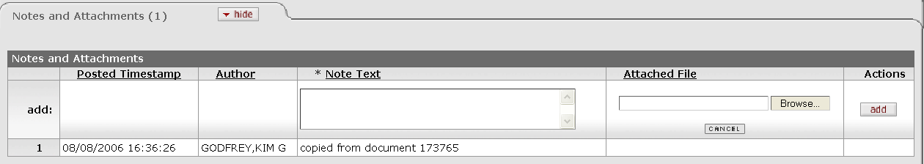
Figure 2-29 Notes and Attachments tab displays a note that the document was copied from another document.

  - Complete required tabs for the document.
The requirements for completion of an e-doc are explained later in the respective chapter for each document type.
  - Click submit to route the document for approval.
For information about routing the document, see “Routing a Document” later in this chapter, page 29.
Lookup and Copy Feature for Chart of Account Maintenance e-docs
If you wish to create a Chart of Accounts code that is similar to one of the existing codes you can click the copy link. The system creates a document with all of the same values, except for the primary key values. This feature is not available for financial transaction documents.
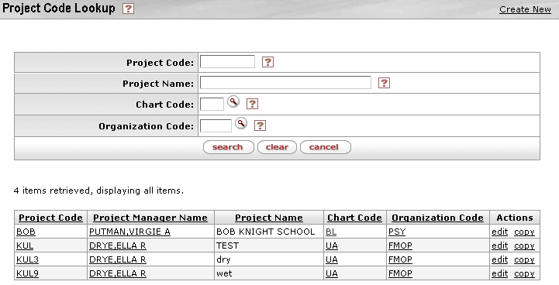
Figure 2-30 Lookup and Copy Feature for the Chart of Account Maintenance E-Docs

Saving a Document
  - To save the document to work on later, click save in the list of workflow action buttons (Figure 2-6).
  - Verify that the document was successfully saved.
The message is displayed in the upper left corner.
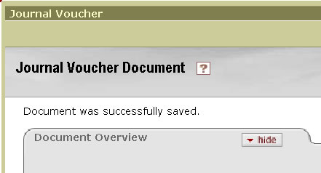
Figure 2-31 The KFS message, 'Document was successfully saved.' confirms that the document was saved.
  - Retrieve the document at a later time to continue working.
For information about how to retrieve an e-doc, see “Searching for a Document” later in this chapter, page 31.

Canceling a Document
  - To cancel the document, click cancel in the list of workflow action buttons (Figure 2-6).
  - When prompted 'Are you sure you want to cancel?' click yes to proceed.
Documents in Initiated status that are canceled are removed from the database and cannot be retrieved or viewed.
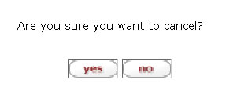
Figure 2-32 When you click cancel, the confirmation dialog is displayed.

Closing a Document
  - To close the document and return to the main menu, click close in the list of workflow action buttons (Figure 2-6).
  - When prompted 'Would you like to save this document before you close it?' click yes to proceed.
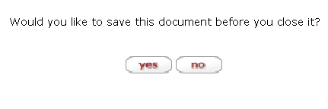
Figure 2-33 When you click close, the confirmation dialog is displayed.
Closing a document in Initiated status has the same effect as canceling the document.

Routing a Document
The e-doc process supports both pre-established Workflow routing and Ad Hoc routing. In the Workflow routing, the KFS routes the document to the proper users based on business rules established in Workflow. Ad Hoc routing allows a user to route the document to one or more individual users and/or workgroups for Approval, Acknowledgement, or FYI.
Unless you wish to add an Ad Hoc routing, select one of the action buttons to route the document in the predefined routing hierarchy.
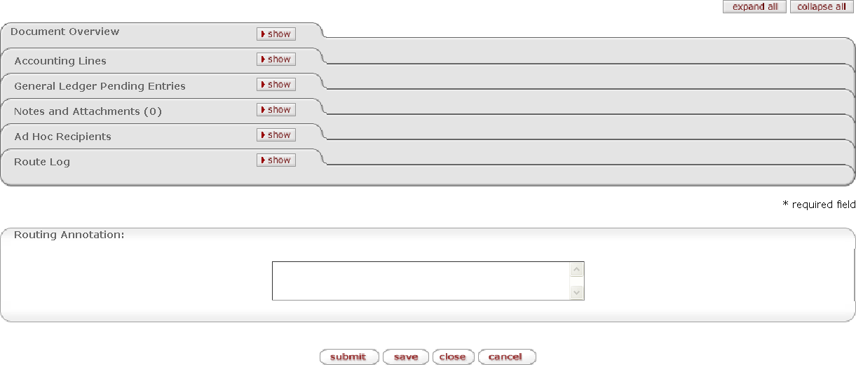
Workflow Action Buttons
Figure 2-34 Routing a Document
For information about document routing, see “Error: Reference source not found” in Chapter 7, page Error: Reference source not found.

Action List
Use Action List located in the upper left corner of the screen to view and act on the documents currently pending your completion, acknowledgement, approval, and FYI.
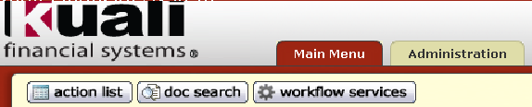
Figure 2-35 The action list buttons
Documents sent to your Action List may request various types of actions from you. The most commonly requested actions are:
- Approve: Verify that the transaction is acceptable. Approved financial documents continue routing to additional approvers, or if fully approved, are included in the next update to the General Ledger.
- Acknowledge: A request to view and acknowledge a transaction, without the need for a formal approval. You must open the document from your Action List to clear it out. This is the type of action request generated back to prior Approvers and the Initiator when a document is disapproved.
- FYI: A courtesy request allowing you to view the transaction or to just clear the request from your Action List without viewing it.

Figure 2-36 Workflow Action Buttons
For more information about the Action List, see "Error: Reference source not found” in Chapter 7, page Error: Reference source not found.

Searching for a Document
Use doc search located in the upper left corner of the screen to edit or view documents.
Figure 2-37 Click Doc Search to search for a document.
  - Click doc search.

  - Enter search criteria.
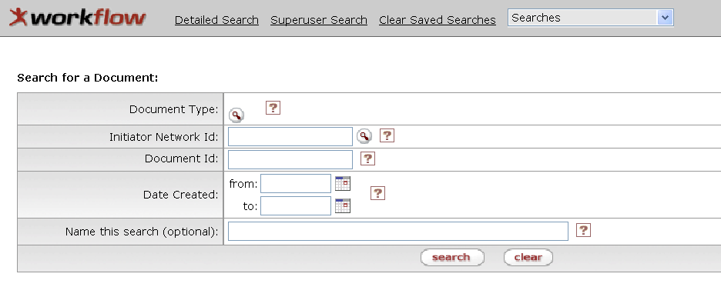
Figure 2-38 Enter your criteria to search for a document.
For the explanation about the search criteria fields, see "Table 2-6 Document Search Criteria" later in this chapter.
  - Click search.
  - Click the Document ID link to open the document, the initiator ID link to retrieve a workflow user report, or the Route Log icon to view the workflow status.
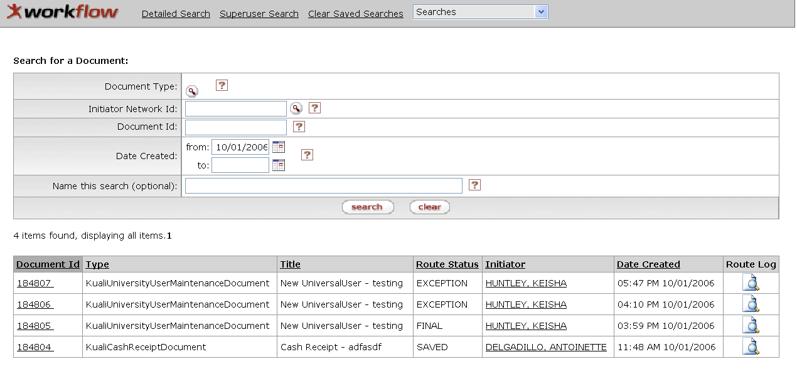
Click the Document ID link to open the document.
Click the user link for a workflow user report.
Click the Route Log to view workflow status.l
Figure 2-39 After searching for a document, you may drill down the Document ID, Initiator or Route Log.
For more information about the drilldown feature see “Drilldown” in the current chapter, page 20 .
Table 2-6 Document Search Criteria
Field | Description
Document Type | Document type. Select the document type from the Document Type lookup .
Initiator Network ID | User ID of the document initiator. Enter the User ID or select it from the UserID lookup .
Document ID | Enter the numeric document ID assigned by the system or select it from the Document ID lookup .
Date Created from/to | Enter or select from the Calendar , the range of document creation dates to search. You may select the From date only or the To date only or both.
Name this search (optional) | If you wish to save the search criteria for future use, enter a name for the search. All saved search are accessed via a list at the top of the document search screen.

Using Wildcards (*) in the Search Criteria
The use of asterisks in the search criteria allows you to perform pattern matching. If you wish to search for documents containing a string of characters in the alphanumeric fields such as the document title, you may enter a character string in the search criteria accompanied by asterisks. For example, enter ‘*test’ to search for a document title that ends with the word ‘test.’ Enter ‘test*’ to search for a document title that begins with the word ‘test.’ Enter ‘*test*’ to search for a document title that has the word ‘test’ somewhere in the document title.
For advanced features of the document search, see “Error: Reference source not found” in Chapter 7, page Error: Reference source not found.

Summary
In this chapter, you were introduced to the KFS architecture and the basic navigation and operations of an e-doc. Topics included are how to logon, how to view a route log, how to create a document, how to route a document, how to access the action list, and how to take appropriate action on a document. Finally, you learned how to set the action list preferences and how to search for documents.

